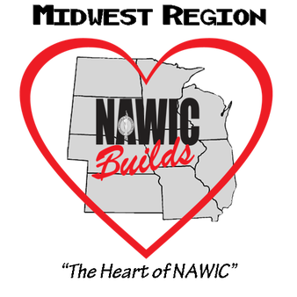
MIDWEST REGION NAWIC
FUTURE LEADER OF THE YEAR
GUIDELINES AND NOMINATION FORM

This award is given annually at the regional Forum of the Midwest Region. The award recognizes a NAWIC Members with LESS 3 years of membership who has been actively involved throughout the past year and has exemplified the spirit and purpose of NAWIC. All nominees must be a member in good standing and a member of the Midwest Region. The member can be nominated by an individual or a chapter.

Nominations must be received by the Regional Awards Chair on or before the due date. Nominations may be mailed or e-mailed. All nominations will be edited to erase any references as to the identity of the nominee and forwarded to a panel of judges as selected by the Chairman. Judges are to be impartial and may include NAWIC members.

NOMINATION FORM

The following member_________________________________________ has been nominated for consideration as Midwest Future Leader of the Year.

I certify that the information contained in the attached application is true to the best of my knowledge and the nominee is a member in good standing of the Midwest Region NAWIC.

____________________________________________ ________________________
Signed Date

NOMINEE #____________

MIDWEST REGION FUTURE LEADER OF THE YEAR
APPLICATION FORM

Nominee joined NAWIC _____________________
(2 point per year with a max of 5)

Chapter Offices Held # of times
(2 point for each year of service; max 5)
President _____________
Vice – President (or President-Elect) _____________
Secretary _____________
Treasurer _____________

Director _____________
Parliamentarian _____________

Membership Recruitment ______________
(1 for each member recruited; max 15)

Chapter Involvement
(max 20)

Committees Chaired ______________
(4 points per chairmanship per year))
Committees served upon ______________
(3 point per committee per year)
Other ______________
(2 point)

Regional Involvement:
(max 10)
Attended Fall Conference _____________
(3 points for each conference)
Attended Annual Forum _____________
(4 points for each Forum)
Chaired Regional Committee ______________
(3 points for each chairmanship)
NOMINEE #____________

National Involvement
(Max 5 Points)
Attended AMEC _______________
(2 points for each year)
National Committee Chair _______________
(2 points for each chair/year)
Other ------------------------
( 2 points; ex Attended Out of Region Event)

NEF Certifications (1 point each) CIT_____ CIS_______CBT______CDS_____CCA_____

Other Construction and/or community services activities (Max points 10)

_______________________________________________________________________________________________________________________________________________________________________________________________________________________________________________________________

Essay in 300 words or less.
Why should this member be chosen as Midwest Region Member of the Year?
(1-25 points)

