July 2020
Field Daily Safety Message
 |  |  | 1  STOP Work Condition | 2  Hazards of Laydown Yards  Insects | 3  Definition of Line of Fire | 4  Avoiding Dog Bites  Dog Bites
5  Coaching Received | 6  Excavating or Drilling? | 7  Know the Symptoms of Heat Stress  HEAT | 8  Water, Rest, Shade | 9  Slips, Trips, and Falls  Slips, Trips | 10  Other Crews Working Near? | 11  Chainsaw Safety  Proper Tools - Cuts
12  I am my Brother’s Keeper | 13  Safe Driving Following Distance | 14  Line of Fire | 15  Heat Exhaustion | 16  If You See a Tick  Insects | 17  Ladder Safety | 18  Dog Bite Prevention  Dog Bites
19  Safety Related Paperwork | 20  Underground Information | 21  Longer Days-Extreme Temps  HEAT | 22  Hierarchy of Controls | 23  Slip, Trips, and Falls  Slips, Trips | 24  Fall Protection | 25  The Right Tool for the Job  Proper Tools - Cuts
26  Lightening Safety Tips | 27  Winch/Jib Line Inspection | 28  Keeping Your Hands Out of the Line of Fire  Line of Fire | 29  Why Safety Talks are Important | 30  Check Your Shoes – Spiders  Insects | 31  Why is Stretching Beneficial?

July 1, 2020
Field Daily Safety Message

What is a STOP Work Condition?

A STOP Work Condition is a situation where the work a person or team is performing becomes unsafe, or the scope of the work has changed beyond what the person or team had planned to do.
It is important to the success of each employee to know his or her limitations and to STOP work when necessary.

Every employee has the authority and obligation to STOP any job at any time when they feel it is necessary to do so.

July 2, 2020
Field Daily Safety Message

Hazards of Laydown Yards

There is a long list of hazards present in a laydown yard depending on what is stored there and the operations that take place in and around them.
Some common hazards to consider are:
- Slip, trip, and fall hazards – This is one of the most common hazards in yards that are poorly organized with items just thrown everywhere. Workers navigating the area are more likely to experience a slip, trip, or fall.
- Struck-by hazards – Yards often have equipment moving in and out of them throughout the day. Moving equipment presents a struck-by hazard for any workers in the area. Stay out of the line of fire.

- Biological hazards – Insects and animals are not often considered when discussing the hazards of a yard. Snakes, ticks, spiders, bees, wasps, and racoons love the shelter of equipment or a pole pile.
Stay alert and aware in all laydown yards to remain Safety Strong.
July 3, 2020

Field Daily Safety Message

What is the definition of Line of Fire?

Being in a position / spot / location while performing or observing work that could get you hit / struck / crushed by an object should it move unexpectedly or in an unplanned direction.

Here are a few examples of Line of Fire scenarios:
- Objects being lifted or hoisted
- Tensioned lines
- Moving vehicles and equipment
- Objects with potential to fall or roll
- High pressure cylinders or hydraulic lines

Ways to prevent Line of Fire exposure:
- Awareness is the first defense
- Perform a job site walk down
- Communicate the hazard with others
- Eliminate the hazard when at all possible

July 4, 2020

Field Daily Safety Message

Avoiding Dog Bites

For employees who work in the field, they understand that dealing with dogs is a common occurrence. We cannot assume all dogs are friendly since we do not understand the owner’s intentions with the dog. By maintaining a questioning attitude, we can ensure that we stay focused around dogs and that will help eliminate the chance of experiencing a dog bite or attack by a dog.

Below are some tips to follow when you encounter dogs in the field:

Never turn your back to a dog.

Have PPE on hand ahead of time and assume you will encounter a dog.

Be prepared when you are working in the field to encounter dogs.

Always ensure you are wearing proper footwear.

Ensure your first aid kit is stocked in case you need to administer first aid.

Maintain a questioning attitude.

Share other “how to avoid dog bites” tips with your team.
July 5, 2020

Field Daily Safety Message

How is Coaching Received?

Do you sometimes hesitate to intervene when you observe a safety weakness?
Perhaps you are concerned about the person reacting negatively. These fears mainly just reside in our heads in today’s safety culture. Most people welcome the coaching and appreciate it.

Next time you observe a safety weakness, try believing they will react positively. You not only will be helping them return to their families safely, but you will also probably be thanked.

July 6, 2020

Field Daily Safety Message

Are you excavating or drilling?
Are you sure there are no underground utilities in the soil you are disturbing?
Sometimes utility markers are not directly above the respective utilities for various reasons or are not there at all. Determining if there are utilities where you are excavating, or drilling should be done through the proper channels.
If you are not sure, bring up your concerns before disturbing soil.

July 7, 2020
Field Daily Safety Message

Know the Symptoms of Heat Stress

Extreme heat can take a heavy toll on you. It can lead to dangerous medical complications, such as heat stress, heat stroke, or death. Everyone must know the signs and symptoms of heat stress. The one suffering may not notice their own symptoms.
Be your brother’s keeper and remain Safety Strong.
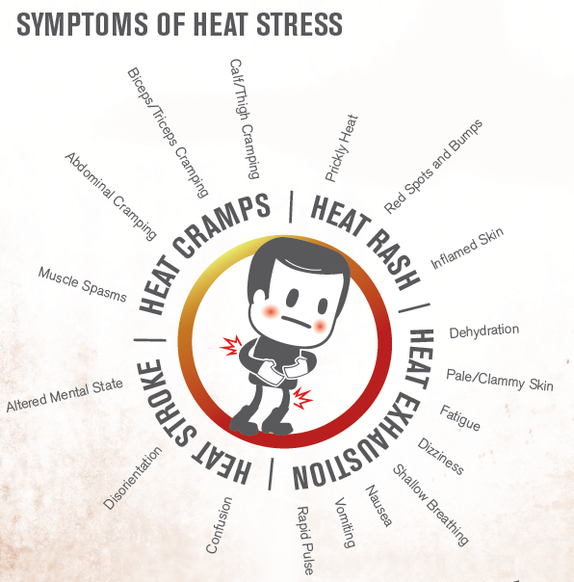

July 8, 2020

Field Daily Safety Message

WATER, REST, SHADE
Remember these three simple words: Water, Rest, Shade. Taking these precautions can mean the difference between life and death.
Any worker exposed to hot and humid conditions is at risk of heat illness, especially those doing heavy work tasks, wearing bulky protective clothing, or working with equipment. Some workers might be at greater risk than others if they have not built up a tolerance to hot conditions, including new workers, temporary workers, or those returning to work after a week or more off.
The risk of heat illness includes everyone during a heat wave.
Take the time to acclimate to the heat!
July 9, 2020
Field Daily Safety Message

Slips, Trips, and Falls

You take hundreds of steps every day, what can you do to prevent a slip, trip, or fall?

- Use good judgement when selecting your footwear for the day’s activities
- Be alert for uneven surfaces, slippery surfaces, and tripping hazards
- Look for transitions between two surfaces
- Always use handrails

Keep your “eyes on path” always and take every single step seriously!

July 10, 2020

Field Daily Safety Message

Are there other crews working near you at a work site?

If so, these crews may have hazards associated with their work which could affect your crew. Your crew could also have hazards associated with your work which could put others crew at risk.

Communication through JHA sharing is a great start to eliminate or mitigate the risk associated with multiple crews working in the same area.

Dare to share!

July 11, 2020

Field Daily Safety Message

Chainsaw Safety

With the storm season upon us, here are a few safety reminders when it comes to chainsaw use:

- Chainsaws shall only be used by a qualified operator
- The chain shall be maintained sharp and with the correct amount of tension in accordance with manufacturer’s operating manual
- The fuel for the chainsaw shall be stored in an approved DOT container
- The immediate work area shall be kept clear to ensure that brush will not interfere with the saw or operator
- Chainsaw shall be operated with two hands at all times
- Chainsaws shall not be used directly over the operator’s head
- The chainsaw must be equipped with a control that will return the saw to idling speed when released
- The chainsaw shall be equipped with a clutch and shall be so adjusted that the clutch will not engage the chain drive at idling speed.
- Chainsaws shall be equipped with a working chain brake

Remember a chainsaw shall be started on the ground or where it is otherwise firmly supported. “Drop starting” of saws is permitted outside of the bucket of an aerial lift only if the area below the lift is clear of personnel.

“Drop starting” is the process of starting a saw by simultaneously pushing it away from the body with one hand and pulling on the starter cord handle with the other hand.

When operating a chainsaw, on the ground, employees shall wear cut resistant leg protection that covers the full length of the thighs to the top of the boots.

July 12, 2020

Field Daily Safety Message

Brother’s or Sister’s Keeper

We often use the phrase “I Am My Brother’s or Sister’s Keeper.”

Take a moment and discuss what that phrase really means to you and your work group. Once an accident occurs it is impossible to take it back.

Ask yourself this question, what would I not do to save my brother’s or sister’s life?
No matter what your job classification is in your work group, if you see something say something.

When safety is first, you last!

July 13, 2020

Field Daily Safety Message

Following Distance

Smith system driving instructs us to maintain a following distance of a minimum of four seconds. However, four seconds is only adequate during good/dry driving conditions and
when in a standard size vehicle.

If you drive a large truck or are pulling a trailer it will take longer to stop. Also, if the driving conditions are anything but dry, it will take longer to stop.

Under these conditions we should allow for an additional minimum two seconds of following distance to safely stop our vehicle, bringing the total to a minimum of six seconds.

Safety habits are a cheap and effective insurance policy.

July 14, 2020

Field Daily Safety Message

Avoiding the Line of Fire
Awareness is the first defense to avoiding the line of fire.
Assess and re-assess your work to avoid line of fire injuries. Use the appropriate human performance tools to mitigate and eliminate the surrounding risks.
Ask yourself these questions:
- "Where am I about to put my hands?”
- "What risk is involved placing my hands here?"
- “What could possibly slip or move while I am performing my work?”
- “What is best body position and motion to prevent my hand from striking an object should a slip or other sudden releases of tension occur?”

July 15, 2020

Field Daily Safety Message

Heat Exhaustion

Heat exhaustion is the most common heat illness. Heat exhaustion is a condition where symptoms may include heavy sweating and a rapid pulse, a result of your body overheating. Causes of heat exhaustion include exposure to high temperatures, particularly when combined with high humidity, and strenuous physical activity.

Signs and symptoms may develop suddenly or over time.
- Cool, moist skin with goose bumps when in the heat
- Heavy sweating
- Faintness
- Dizziness
- Fatigue
- Weak, rapid pulse
- Low blood pressure upon standing
- Muscle cramps
- Nausea
- Headache

If you think that you are experiencing heat exhaustion, stop all activity and rest, move to a cooler place, and drink cool water or sports drink. Consult a doctor if your signs or symptoms worsen or don’t improve within an hour.

If you are with someone showing signs of heat exhaustion, seek medical attention if the person becomes confused or agitated, loses consciousness, or is unable to drink.

July 16, 2020

Field Daily Safety Message

If You Find a Tick on You!
It is important to remove the tick as quickly as possible. Removing the tick quickly can prevent the spread of disease if the tick is infected.
- Use fine tip tweezers to remove the tick
- Make sure the head of the tick is removed with the body
- Save the tick in a zip lock bag or container in case it needs it needs to be identified later if disease occurs
- Wash the area with soap and water after the tick is removed as well as your hands
- Apply antibiotic ointment to the area if the bite becomes irritated
Don’t take ticks home with you on your skin and in your clothes, they don’t make good house guests.
Check yourself!

July 17, 2020

Field Daily Safety Message

Ladder Safety
Always maintain three points of contact while ascending and descending a ladder, that’s either both feet and at least one hand or both hands and one foot.

Portable ladders should be long enough to be placed at a stable angle and extend three feet above the work surface. Workers should tie ladders to a secure point at the top and bottom to avoid sliding or falling. Tools and materials should be carried up using a tool belt or a rope to pull things up once you’ve stopped climbing.

Never load ladders beyond their rated capacity, including the weight of the worker, materials and tools.

“While on a ladder, never step back to admire your work.”

July 18, 2020
Field Daily Safety Message

Dog Bite Prevention
Dog attacks can be as minor as a small single bite to as serious as death. It is now estimated that over 40% of all households have at least one dog. Because of this number the chance of encountering an aggressive dog is very high.
Here are a few tips:
- Never turn your back to a dog, this is a sign of weakness
- Have your PPE available and in hand if possible before an encounter
Don’t get complacent, just because the dog recognized you the last time does not mean he still feels the same way this time

July 19, 2020

Field Daily Safety Message

Safety Related Paperwork
Whether you agree or disagree with the paperwork that the company requires you to review or complete relating to safety on the job, each piece is there for a reason. There are many proactive tools such as training materials, job hazard analyses, PPE assessments, standard operating procedures, and documentation of incidents. These tools are meant to communicate the hazards and necessary measures needed to work safely for a specific work task or at a work site. These tools also get everyone to step back and focus on safety rather than just jumping into a work task and act as a safeguard prior to work beginning.
Just don’t go through the motions and pencil whip paperwork. Take time to make sure that everyone understands the purpose of these tools.
It is just another way to keep us Safety Strong!
July 20, 2020

Field Daily Safety Message

Underground Work Safety Reminders

As a reminder, all URD equipment and conductors shall be treated as energized until approved testing methods confirm that they are de-energized.

- All switching, tagging, and grounding rules shall be followed when de-energizing lines and equipment.
- Door hinges of each enclosure shall be checked before it is opened.
- Both hands shall be used to keep positive control of the lid and of the enclosure.
- Doors shall be blocked so that they cannot close accidentally. Do not leave doors open while unattended.
- Primary rated rubber gloves, EH/Dielectric footwear, hard hat, and approved eye protection shall be worn when opening or closing an energized pad-mount transformer or switching cabinet.

Keep your head and your hands on the same page when dealing with URD work and remain Safety Strong.

July 21, 2020

Field Daily Safety Message

Longer Days and Extreme Temperatures

Longer days, extreme temperatures and humidity, and blistering sun come together to create the perfect conditions for an accident or injury. Compiled below are 10 summer work safety tips to help protect us from common summer hazards:

- Drink plenty of water – it is recommended to drink fluids every 15 to 20 minutes to stay cool and alert
- Get out of the heat – find cool, shady areas for rest breaks and encourage all to take preventive cool-downs when they feel they need to do so
- Train employees on first aid for heat-related illness – make sure that everyone knows the signs and symptoms, be your brother’s keeper. If you notice something that is not quite right, say something
- Prevent mosquito-borne illnesses – use your Buzz Up insect repellent
- Protect your eyes and skin from UV exposure – eye protection and long sleeves
- Don’t skimp on PPE – it may be tempting to ditch PPE in hot weather which can put you at risk for injury
- Revisit safe driving practices – with more drivers on the road, the summer months can be a dangerous time to drive
- Get enough rest – heat, longer days, and busy weekends can leave us feeling sluggish, which increases our risk of injury
- Conduct severe weather drills – thunderstorms and tornadoes are common during the summer months, so it is important that we all know what to do in the case of severe weather
- Keep indoor spaces cool, too – adequate ventilation and cooling are especially important for labor intensive and high-heat activities during the hot summer months

Stay safe and always remember – WATER, REST, SHADE

July 22, 2020

Field Daily Safety Message

Hierarchy of Controls for Safety

The idea behind this hierarchy is that control methods at the top of the list are potentially more effective and protective than those at the bottom.

- Elimination is the most effective way to reduce hazards but sometimes can be the most difficult to implement. By working de-energized, we have eliminated the possibility of a flash.
- Substitution is a way to remove a hazardous situation and replace it with a less hazardous situation. Are we using to right tool or equipment for the job?
- Engineering Controls are used to remove a hazard or place a barrier between the employee and the hazard. Often older equipment works well but may not have the safeguarding that newer equipment may have.
- Administrative Controls are frequently used with existing processes where hazards cannot be controlled by elimination, substitution, or engineering. Administrative controls are policies and/or procedures which explain how to perform a job or task.
- PPE does not eliminate a hazard; it only serves as a barrier. If the barrier is breached, you are now exposed to a hazard.

PPE is always a last resort and should never be looked at as a primary control for a hazard. The more safeguards in place for a hazard the least likely an incident will occur.

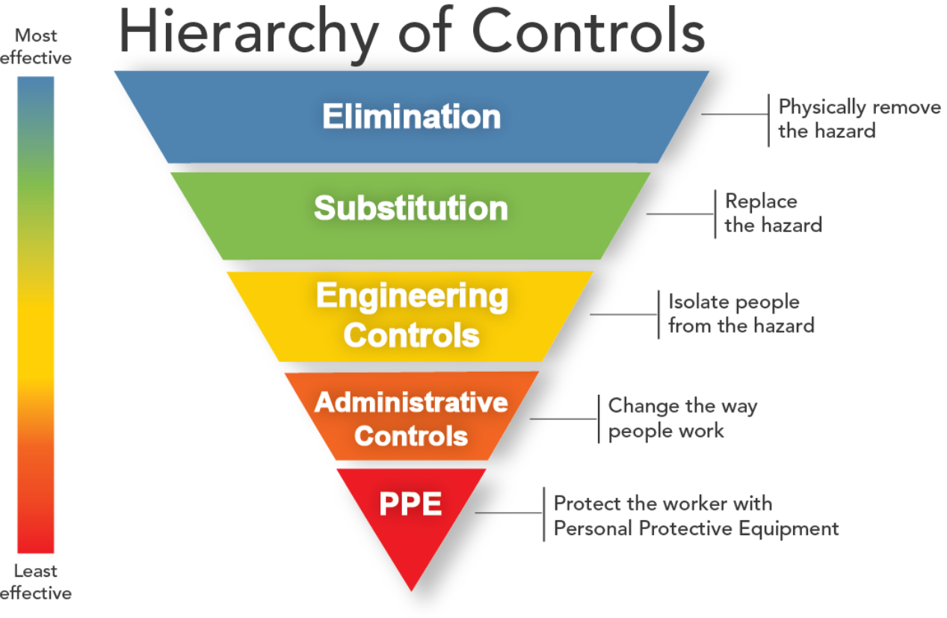

July 23, 2020

Field Daily Safety Message

Slips, Trips, and Falls

As the second most prevalent cause of nonfatal occupational injuries, it is vital to ensure that our work area is kept clean to prevent employees from tripping or slipping. If you are dealing with a liquid, use drip pans and guards. Clean up any spills immediately to keep conditions safe.

Also check your workplace to make sure there are no holes, loose boards, or nails projecting from used pallets. If a potential slip, trip, or fall hazard exist, remove it from the work area immediately.

“A spill, a slip, a hospital trip.”

July 24, 2020

Field Daily Safety Message

Fall Protection

Never put on a fall protection harness until you’ve inspected it properly.

While inspecting your harness, check all straps, buckles, D-rings, and lines for any sign of damage or wear.
Next, follow manufacturer instructions for putting the harness on, and then check to make sure you’ve properly fastened and adjusted all straps. Never start work and begin working at heights unless you’re fully satisfied with the condition and the fit of your harness. Talk to your supervisor and/or get a different harness if there’s a problem

Be sure your lanyard is attached to the D-ring on your fall arrest harness at one end and is attached securely to an approved anchor point at the other end. Remember that a guard rail is NOT an anchor point.

July 25, 2020

Field Daily Safety Message

The Right Tool for the Job

Ensuring that everyone has the right tool for the job is vital to safety success. Each tool is precisely designed for a specific purpose. Choosing the correct tool will also decrease the amount of effort required to get a job done right without causing damage to either the equipment, the surface being worked, or the employee.

Common injuries from improper use or selection of tools include cuts, punctures, scrapes, abrasions, eye injuries, bruises, carpal tunnel and electrical shock/ burns from contact with energized equipment.

Employees should always take time to consider the best tool for each task and wear proper PPE during each use.

July 26, 2020

Field Daily Safety Message

Lightning Safety Tips

Lightning, it may look cool when you see it streak across the sky, but it is also an incredibly dangerous, unpredictable force of nature. It is hotter than the surface of the sun and strikes the United States approximately 25 million times a year. If you see a lightning bolt, even if it seems far away, it is important to act quickly and get yourself to a safe place to wait out the storm.

- During a thunderstorm, NO PLACE is safe from a lightning strike
- If you cannot see lightning but you hear thunder, lightning is close enough to strike you
- A substantial, enclosed building or a metal-topped vehicle are the safest places to wait out a storm

“Never give safety a day off.”

July 27, 2020

Field Daily Safety Message

Winch/Jib Line Inspection

Have you inspected your winch and/or jib line from end to end recently?

Take time to perform a full inspection of the winch/jib system. Use this time to teach others how to properly perform the inspection and what PPE and techniques to use while doing so.
- Identify a safe location to setup your vehicle.
- Perform a visual inspection before putting the winch/jib into operation.
- Check the controls. Operate the winch/jib by paying out and back in.
- Pay the line out to perform a thorough inspection of the entire line.
- Be sure to roll the lineup evenly and tightly so that the line does not bind onto itself the next time you operate it.

“When it doubt, check it out.”

July 28, 2020

Field Daily Safety Message

Hand Safety

During rigging activities, the sudden urge to maneuver a piece of wood under a load when landing it or moving something out of the way at the last minute while the load is being set, could have the potential to cause great injury.

We always want to be mindful of where we are placing our hands during any material handling activity, don’t pass or reach under a load. If the wood you are landing the load on needs adjusting, use a pole or something other than your hands to make the adjustment.

Do not place your place your hand where you can’t see it, you may not get it back.

July 29, 2020

Field Daily Safety Message

Why Safety Talks Are Important

When done correctly safety talks can have a profound effect on the overall safety at a workplace. Companies who spend the time to conduct these meetings are less likely to have injuries compared to a company who does not hold them on a regular basis.
Conducting safety talks often is an effective way to deliver relevant and timely safety messages to an entire work crew. The time spent conducting these talks also goes a long way into reinforcing prior safety training.
Even just holding a 5-minute safety meeting everyday equates to a massive amount of safety knowledge for your work force over a years’ time.
To be exact- it results in over 20 hours of safety education per employee a year! (5 minutes X 5 workdays per week X 50 work weeks= 1250 minutes… 1250 minutes/60 minutes per hour= 20.8 hours of safety education)
Imagine the difference that education can make if you make the most out of every safety talk!

July 30, 2020

Field Daily Safety Message

Check Your Shoes

Did you know that your shoes are considered a safe hiding spot for spiders?

According to the University of California, all our Entergy service territory is in high range for brown recluse spiders. These are not the only spiders that can harm you if bitten though. Before you put on your shoes, turn them upside down and shake them to allow any spiders that may be hiding inside to get out. Consider not storing shoes in your garage, where spiders are more likely to live. You can also visually inspect the inside of the shoe before putting on to ensure no spiders are inside.

The last thing anyone needs is to be bitten by one of these things when you least expect it!

July 31, 2020

Field Daily Safety Message

Why is Stretching Beneficial?

Stretching improves flexibility and joint range of motion. When you stretch your muscles, the connective tissue around the muscles, and the fibers elongate allowing the stretched muscles to become longer which increases your flexibility.

Here are 9 benefits of stretching:
- Increases flexibility
- Increases your range of motion
- Improves your performance in physical activities
- Increases blood flow to your muscles
- Improves your posture
- Helps to heal and prevent back pain
- Is great for stress relief
- Can calm your mind
- Helps decrease tension headaches

Stretching is not only for mornings, stretching is beneficial throughout your day!

