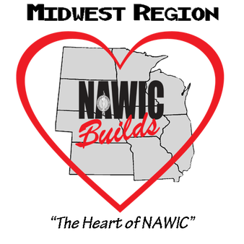
MIDWEST REGION NAWIC
MEMBER OF THE YEAR
GUIDELINES AND NOMINATION FORM

This award is given annually at the regional Forum of the Midwest Region. The award recognizes a NAWIC Members with more than 3 years of membership who has been actively involved throughout the past year and has exemplified the spirit and purpose of NAWIC. All nominees must be a member in good standing and a member of the Midwest Region. The member can be nominated by an individual or a chapter.

Nominations must be received by the Regional Awards Chair on or before the due date. Nominations may be mailed or e-mailed. All nominations will be edited to erase any references as to the identity of the nominee and forwarded to a panel of judges as selected by the Chairman. Judges are to be impartial and may include NAWIC members.

NOMINATION FORM

The following member_________________________________________ has been nominated for consideration as Midwest Member of the Year.

I certify that the information contained in the attached application is true to the best of my knowledge and the nominee is a member in good standing of the Midwest Region NAWIC.

____________________________________________ ________________________
Signed Date

NOMINEE #____________

MIDWEST REGION MEMBER OF THE YEAR
APPLICATION FORM

Nominee joined NAWIC _____________________
(1 point per year with a max of 10)

Chapter Offices Held # of times
(1 point for each year of service; max 10)
President _____________
Vice – President (or President-Elect) _____________
Secretary _____________
Treasurer _____________

Director _____________
Parliamentarian _____________

Membership Recruitment ______________
(1 for each member recruited; max 15)

Chapter Involvement
(2 points for each chairmanship, 1 point for committee member; max 10)

Committees Chaired ______________
(2 points per chairmanship per year))
Committees served upon ______________
(1 point per committee per year)
Other ______________
(1 point)

Regional Involvement:
(max 15)
Attended Fall Conference _____________
(3 points for each conference)
Attended Annual Forum _____________
(4 points for each Forum)
Chaired Regional Committee ______________
(3 points for each chairmanship)
NOMINEE #____________

National Involvement
(Max 10 Points)
Attended AMEC _______________
(2 points for each year)
National Committee Chair _______________
(2 points for each chair/year)
Other ------------------------
( 2 points; ex Attended Out of Region Event)

NEF Certifications (1 point each) CIT_____ CIS_______CBT______CDS_____CCA_____

Other Construction and/or community services activities (Max points 5)

_______________________________________________________________________________________________________________________________________________________________________________________________________________________________________________________________

Essay in 300 words or less.
Why should this member be chosen as Midwest Region Member of the Year?
(1-20 points)

